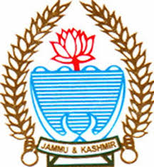
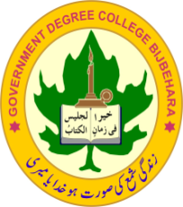
Office of the Principal Govt. Degree College
Bijbehara-Kashmir-192124
Website: www.gdcbijbehara.net # E-Mail: principalbijbehara@gmail.com
Tele/ Fax. No.: 01932-233263 Cell No: 94190-40756

PRESS RELEASE

Department of Education ,Govt Degree College, Bijbehara organised a Two Day National Webinar on the Theme, “Understanding NPE 2020: An Academic Perspective” on 22nd and 23rd of August,2020.
On day first of the Webinar, the formal Welcome Address was presented by Madam Principal, Prof.Nighat Fatima wherein she formally welcomed all the guests and participants across the Country .Presenting an overview of the theme, she expressed hope that Higher Education Department of JK UT will take a lead in the speedy implementation of the path-breaking Policy.
Thereafter the Webinar was virtually Inaugurated by the Worthy Commissioner Secretary, Higher Education, Mr. Talat Pravez Rohella. During his Inaugural Speech he beautifully explained the crux of NPE 2020 and shared his insight about the said Document with much emphasis on the vocationalization of Education
On day 1st, the guest speaker was Prof. Arvind Kumar Jha, Dean School of Education,B. R. Ambedkar University, Lucknow. He enlightened the participants with his expertise and treasure of knowledge about the Policy. He deliberated on the five basic foundational pillars of the Policy i.e, Access, Equity, Quality, Affordability and Accountability, that aims at transforming India into a vibrant knowledge society and global knowledge superpower .The second speaker of the Day 1st was Mr. Mohammad Rafi, Ex. Director and Mission Advisor of School Education Department, J&K. The speaker highlighted the theme in the context of historical background since Independence. At the end of the Session the Experts answered the queries of participants to their utmost satisfaction related to the theme.
Director Colleges, Prof Yaseen Ahmad Shah, presented the concluding remarks during the Webinar. He deliberated upon some vital issues pertaining to the Policy and reiterated the role of teachers in the implementation of the Policy in its real spirit. Finally, Dr S.M Zubair proposed Vote of Thanks. The Moderator for the day 1st was Dr Mehraj Ahmad Bhat , Assistant Professor, Department of Education.
On the day 2nd of the Webinar, the Session was started by Mr. Showkat Ahmad Malik, (Assistant Professor) Moderator of the Session by highlighting some important aspects of the Policy which were deliberated on day first. Prof Ab. Salam Dar (HOD Education) welcomed the guests and other participants. The First Guest speaker during the Session was Prof. Vishal Sood, Dean School of Education, Central University of Himachal Pradesh. Prof Sood presented the Pros and Cons of the Policy with some valuable inputs for its review. The second speaker during the session was Dr. Firdous Ahmad Sofal, Coordinator, Teacher Education Department, Central University of Kashmir. Dr.Sofal highlighted the theme with much focus on ECCE, Physical and Digital Infrastructure, Teacher Education and Quality Research in context of NPE 2020. At the end Question Answer Session was held, wherein both the experts answered the queries of participants in a lucid manner concerning the theme.
At the Culmination of the Webinar, Dr Mehraj Ahmad Bhat presented a formal Vote of Thanks to the Guests and Participants .

Prof. Nighat Fatima Media Secretary
Principal

